**FYP II Final Report**

**Drone Navigation using Brain-Computer Interface (BCI)**

**Project Code : 19S-16**

**Project Supervisor : Dr. Ahsanullah Abro**

**Project Co-Supervisor : Dr. Ahmed Ali Shah**

**Project Manager : M Raheal Safdar**

**Project Team : Naneeta, Madiha**

**Submission Date : 15 - January - 2023**

**_________________________________**

**Signature of the Project Supervisor**

**Document Information:**

| Category | Information |
| --- | --- |
| Customer | Sukkur IBA University |
| Project Title | Drone Navigation using Brain-Computer Interface (BCI) |
| Document | FYP II Final Report |
| Document Version | 1.0 |
| Identifier | 19S-16 Final Report |
| Status | Final |
| Author(s) | M Raheel Safdar, Madiha, Naneeta |
| Approver(s) |  |
| Issue Date |  |
| Distribution | 1. Advisor/Supervisor 2. Project Manager |

**Definition of Terms, Acronyms and Abbreviations:**

| Term | Description |
| --- | --- |
| BCI | Brain-Computer Interfaces |
| ML | Machine Learning |
| EEG | Electroencephalography |
| CNN | Convolutional Neural Network |
| PSD | Power Spectral Density |
| Tello EDU | A brand of drone |
| Arduino | A brand of microcontroller |
| Ag/AgCl | Silver-Silver Chloride |

**DEDICATION**

This report is a tribute to our cherished parents and teachers, who have served as a continual source of motivation and have provided us with financial, moral, and spiritual support when we were on the verge of giving up. Especially, to Late Prof. Nisar Ahmed Siddiqui, who provided us the opportunity to study at such an esteemed institution.

**ACKNOWLEDGEMENTS**

We sincerely thank the Almighty God for providing us with the knowledge we needed to plan and carry out this project. Never was there a shortage or a need. He took charge of anything that could have gotten in the way of this development and supported us through the toughest times.

We respect the Late Professor Nisar Ahmed Siddiqui, the Vice Chancellor of the great institution, because he has pursued God's guidance and creation and nurtured the vision of Sukkur IBA University, a diverse and a world-class institution where we were educated to compete and succeed in the entire world. We cannot disregard the head of the department of computer science and other faculty members who pay attention to and behave in a way that benefits students. Nevertheless, our teachers encouraged and aided us in achieving our objective.

**Table of Content**

**PROJECT ABSTRACT** 5

**RELEVANT BACKGROUND** 5

**1)** **Introduction:** 5

**2)** **Intended Audience:** 6

**3)** **Project Scope:** 6

**4)** **Summary:** 6

**PROPOSED APPROACH** 7

**1)** **Dataset Discussion:** 8

**2)** **Signal Acquisition:** 8

**3)** **Artifacts Removal:** 9

**4)** **Feature Extraction:** 10

**5)** **Model Training and Fine Tuning:** 11

**6)** **Drone Control Paradigm:** 13

**EVALUATION TESTBED** 13

**RESULTS AND DISCUSSION** 14

**LIMITATIONS AND FUTURE WORK** 14

**1)** **Limitations:** 14

**2)** **Future Work:** 14

**REASONS FOR FALIURE *(If Any)*** 15

**PROJECT MANAGEMENT UTILITY** 15

**REFERENCES** 16

# **PROJECT ABSTRACT**

The Brain Computer Interfaces (BCIs) have been widely studied as a promising area of research in the field of Human-Computer Interaction (HCI). The optimal location for BCIs is at the intersection of human and machine adaptability. This project aims to design and develop a BCI that uses electroencephalogram (EEG) to detect and translate a user's neural actions and activities into navigational cues for controlling drones in three-dimensional (3D) physical space. The system will allow users to control a flying robot, or drone, in six directions: up, down, left, right, forward, and backward. The non-invasive EEG headset will be placed on the user's scalp to detect and record the electrical activity of the brain's surface layer. The developed BCI will make life easier for not only normal people but also for people with special needs such as stroke patients or those with motor impairments. The aim is to navigate the drone in six directions by wearing the headset and giving specific commands in the form of brain signals.

# **RELEVANT BACKGROUND**

## **Introduction:**

Brain-Computer Interfaces (BCIs) have been widely studied as a promising area of research in the field of Human-Computer Interaction (HCI) for people with disabilities. According to the World Health Organization's global report [1] in 2011, one out of every five individuals on the planet Earth is disabled. These individuals often have fascicle diseases such as Amyotrophic Lateral Sclerosis (ALS), vertebra damage, ischemic stroke, and other conditions that cause the loss of voluntary muscle control [2]. These people are typically confined to a wheelchair or a bed, and they have significant obstacles in modern society because of their limitations and disability to perform basic activities such as playing games or conversing with others. These activities are essential for individual growth and have a significant influence on one's quality of life. In recent years, cutting-edge technology such as BCIs has become more widely available to the public, and it is our moral obligation to use such advancements to eliminate barriers and allow impaired individuals to resume a normal life.

BCIs combine brain and machine integration, providing a communication channel between the brain and an externally controlled device. The brain-computer interface converts users' intentions, which affect the encephalographic signal, into control signals for a variety of external electronic equipment [3]. Electroencephalography (EEG) is a method used to record brain waves and transmit them to a computer, which then converts the signals into data. The EEG equipment is an example of this technology. This information is then transformed into commands for a computer-connected device.

Delta, Beta, Theta, Alpha, and Gamma are some of the several packets that make up EEG signals. Each packet corresponds to a different sort of mental activity [4], and the strength of these bands is periodically changed throughout the day. The strength of distinct EEG bands is closely related to the brain's activity and state of consciousness [2].

Previous studies have shown that BCI-based drone control systems have great potential for usage in virtual reality, allowing the user to control the drone using their brain activity in first-person view mode. In this project, we aim to develop a BCI system that controls a Tello EDU drone's movements using human brainwaves. The following sections will include an intended audience, project scope, proposed approach, dataset discussion, system architecture, signal acquisition, artifact removal, feature extraction, evaluation testbed, result and discussion etc.

## **Intended Audience:**

This project is intended to be used by a wide range of individuals, including people with disabilities and those who are interested in the field of brain-computer interaction. The updated version of our project, in the form of a product, can be sold to a variety of customers in the neuroscience market.

## **Project Scope:**

The scope of this project is to provide an innovative approach for controlling a drone using a Brain-Computer Interface (BCI), which will replace the traditional remote controller and mobile app. The system will allow the user to wear an EEG headset while sitting on a chair in the required environment and then to control the drone's movement by thinking of each direction one by one. The final system will include an EEG headset, a drone, and a PC or desktop, which will be used to establish communication between the EEG headset and the drone. The goal of this project is to design a user-friendly and easy-to-use assistive technology for drone piloting that will improve the quality of life for people with disabilities.

## **Summary:**

This chapter provides an overview of the project, including its introduction and the features offered by the project. The proposed approach for controlling a drone using a Brain-Computer Interface (BCI) is discussed in chapter 2. The evaluation testbed used to test the system's performance is covered in chapter 3. Results and discussion are presented in chapter 4, which includes an analysis of the data collected during the experiments. Chapter 5 covers the limitations and future work, discussing areas where the project could be improved or expanded upon. Reasons for failure, if any, are discussed in chapter 6. In chapter 7, a detailed discussion of the results and their implications is provided. Chapter 8 covers the project management utility and the tools and techniques used to organize and complete the project. Finally, chapter 9 provides a list of references used in the research and writing of the report.

# **PROPOSED APPROACH**

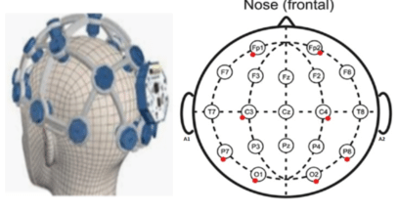The proposed system will have the following architecture: starting with the headset, OpenBCI will be used for brain signal acquisition from the subject's mind via the scalp from different channel locations as shown in Figure 1. The signals will be transferred to a computer via Bluetooth. The signal will be received by the OpenBCI-GUI that allows you to view your EEG data, interpret your results, and creates a window into your brain like never before. We will build a python program at the backend that will act as an intermediary between brain signal acquisition and the drone. This program will be accountable for receiving raw signals from the OpenBCI software, applying preprocessing on the signals, and using a machine learning (ML) model for signal classification and to transfer it to the drone.

Figure : Location of the eight channels (Cyton) in OpenBCI Ultracortex Mark IV

The ML model is the "object" that remains after a machine learning algorithm is applied to training data, and it contains the rules, numbers, and other algorithm-specific data structures that are required to create predictions. The backend python program will generate an output command that will act as an input for the drone, and these signals will be transferred to the drone via Wi-Fi. The drone we will be using is Tello EDU. The Drone is programmed in python and can be attached to desktop, laptop or remote controller using the Wi-Fi technology.

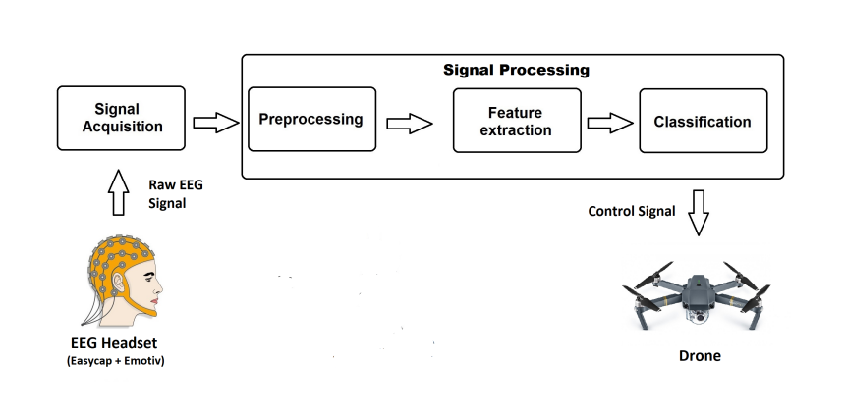The proposed approach for our system is incremental, where the integration of the next module is dependent on the output of the previous module. For example, the signal acquisition module gives data files, which will then be given to the pre-processing module, and then the pre-processed signals will be given to the model for the classification of the signal. The proposed system architecture is shown in Figure 2.

Figure : Proposed System Architecture

## **Dataset Discussion:**

The dataset that we have used for this project is an EEG dataset available on Kaggle. This dataset includes 180 files, with 30 files for each class. Each file has about 3,840 rows, which means it contains 15 seconds of data with a sampling rate of 256 Hz. The dataset includes six classes, namely (left, right, up, down, forward, backward). The OpenBCI headset was used to record this dataset, and 30 subjects aged between 18-26 were selected to collect the dataset. This dataset will be used to train and test the machine-learning model that will be used to classify the brain signals and control the drone's movement.

## **Signal Acquisition:**

In the proposed approach, several frequency bands like Delta, Beta, Theta, Alpha, and Gamma make up EEG signals. Each pack corresponds to a different sort of mental activity. For the project, the alpha band is used, which ranges from 8 Hz to 13 Hz and is related to a state of consciousness, but not of concentration. To isolate this band from the rest, a one-dimensional digital band-pass filter with Butterworth topology is implemented in each of the channels.

We acquired the EEG signals with respect to drone control scenarios using the OpenBCI Ultracortex Mark IV headset. The Ultracortex is an open-source, 3D-printable headset designed to work with the OpenBCI system. It is a tool for recording research-grade brain activity (EEG). EEG signals were acquired using eight Ag/AgCl electrodes following the 10-20 international systems. The Ultracortex Mark IV Headset (Cyton board is mounted on the head cap) as shown in Figure 3. The eight Channels are Fp1, Fp2, C3, C4, P7, P8, O1 and O2 and 2 reference electrodes as shown in figure 1. These two ear clip electrodes, which come with the headset kit, serve as the reference and bias (ground with common-mode noise rejection) for the EEG system. The ground and reference channels were FCz and FPz positions, respectively. The data 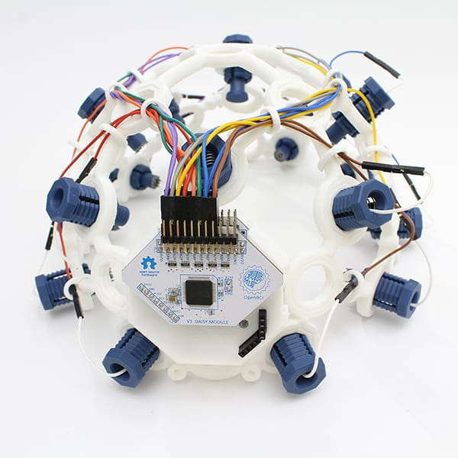of four channels was discarded as the main channels were four namely O1, O2, C3, C4.

Figure : EEG Headset

In the experimental environment, EEG signals will be captured by the EEG headset in real-time from the user's scalp and will be processed simultaneously to generate control commands. The environment must be noise-free in order to avoid any hurdles in focusing the subject to think of the specific direction. The participant wearing the headset will be instructed to avoid unnecessary movements during the experiment. The subject is asked to think of the directions that we have implemented in our project, and those signals are captured. Each direction's signals are captured for 25 seconds for every direction from the subject. From each 25 seconds long signal data, we will discard the baseline of 5 seconds from the start and 5 seconds from the end. The sampling rate was set to be 256 Hz. This process will ensure that the captured signals are clean and free of any noise or artifacts, providing accurate and reliable results.

## **Artifacts Removal:**

Several methods can be used to remove artifacts from EEG signals in visual imagery signal acquisition. Some common methods include:

*Eye Movement Correction:* This involves identifying and removing artifacts caused by eye movements and blinks. This can be done using algorithms that detect changes in the EEG signal that are indicative of eye movements and then subtracting this artifact from the signal.

*Independent Component Analysis (ICA):* This statistical method can be used to separate the EEG signal into independent components, each of which represents a different source of activity in the brain. This can be useful for identifying and removing artifacts that are not clearly associated with eye movements.

*Temporal Signal Averaging:* This method involves averaging multiple EEG trials over time to reduce the impact of artifacts on the signal.

*Filtering:* This involves using mathematical algorithms to remove unwanted frequency components from the signal. Common filters used in EEG include high-pass, low-pass and band-pass filters.

*Rejection of bad channels:* this involves identifying the channel whose signal is bad/noisy and removing it from the data analysis.

The best method for removing artifacts will depend on the specific characteristics of the EEG signal and the nature of the artifacts present. By applying these methods on the captured signal, we will be able to improve the accuracy and reliability of the signal, and ultimately the performance of the BCI system.

## **Feature Extraction:**

To navigate a drone using EEG data in six directions, it is important to extract relevant features from the EEG data that can be used to classify the imagined movements. Some common features that could be extracted from visual imagery EEG data include:

*Power Spectral Density (PSD):* PSD is a measure of the power of the EEG signal at different frequencies. It can be used to identify changes in specific frequency bands, such as the alpha, beta, theta, and gamma bands, that are associated with visual imagery and cognitive processes.

*Event-related potentials (ERPs):* ERPs are specific patterns of brain activity that occur in response to a specific event or stimulus. They can be used to identify changes in the EEG signal that are specific to different imagined movements.

*Spatial filters:* Spatial filters are mathematical operations applied to the EEG data to enhance or suppress certain spatial patterns. They can be used to extract spatial information from the EEG data that can be used to classify different imagined movements.

*Time-frequency analysis:* Time-frequency analysis is used to examine how different frequency bands of the EEG signal vary over time. This can be useful in identifying changes in the EEG signal that are specific to different imagined movements.

## **Model Training and Fine Tuning:**

The system can be divided into two different operation modes: model training and online operation. The first one is dedicated to the training and testing of models on the available dataset and online mode then uses these models to process the EEG data in real time and pass it to the drone. The Machine Learning pipeline adopted in our system is shown in Figure 4.

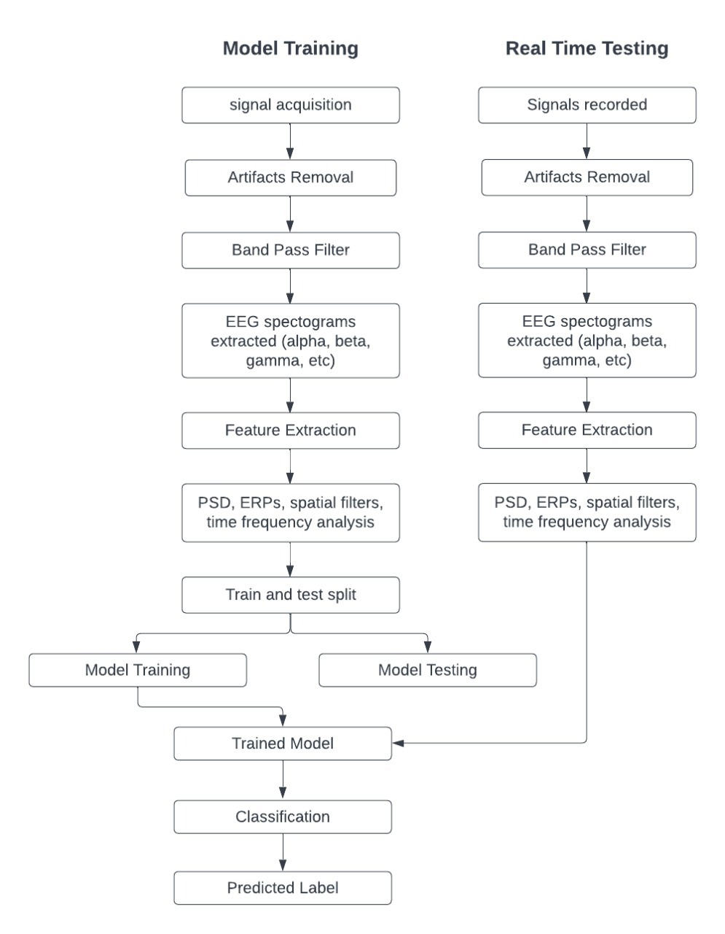For the model training, we went through many traditional machine-learning algorithms like SVM, LDA, KNN and perceptron but they showed poor performance on EEG data.

Figure : Machine Learning Pipeline Flowchart

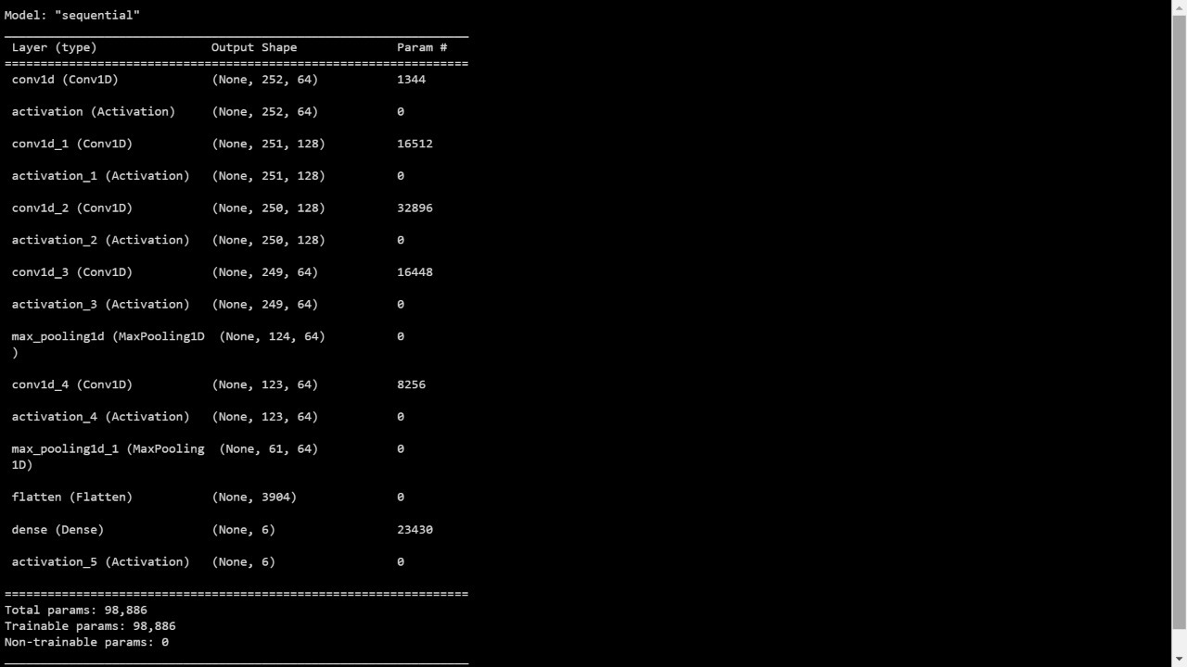Next approach that we have taken is splitting the data into 1 sec window size. Every file has about 3,840 rows, which is 15 seconds data. Each file was segmented into 15 segments and each segment with 1 sec data (256 rows). After segmentation total files became 2700 and 80% of this data was used for training and remaining for testing. That raw data was fed to CNN with 100 epochs and 32-batch size it showed about 90% accuracy on training data and 52% accuracy on testing. The CNN architecture of the model is shown in Figure 5.

Now coming towards second mode, which is online operation, and for online operation we have used the model with 52% accuracy, as this is the model with highest accuracy that we have achieved until now. The python code records the data in real time, pass that data to trained model and model will predict the class, and pass the label to simulation platform.

Figure : ML model Summary

## **Drone Control Paradigm:**

The drone control paradigm is comprised of the following steps:

*Command Generation:* Once the predicted label of drone direction is obtained, it needs to be mapped to specific drone commands. For example, a predicted label of "up" might correspond to a command to increase the drone's altitude.

*Sending Command:* The final step is to send the generated commands to the Tello EDU drone control panel, which will then execute the commands and control the drone's movement. This can be done via a serial connection, or by using the Tello EDU SDK, which allows for programmatic control of the drone.

# **EVALUATION TESTBED**

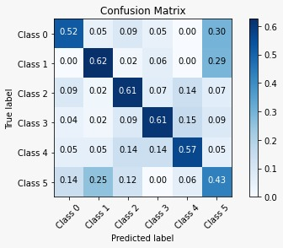To evaluate the performance of the underlying model, we will use a number of metrics, including accuracy, precision, recall, and F1-score. These metrics will be calculated for each class, as well as for the overall model performance. We had used confusion matrix to visualize the model's performance. It is a table used to define the performance of a classification algorithm. Each column of the matrix represents the instances in a predicted class while each row represents the instances in an actual class. The diagonal elements represent the number of points for which the predicted label is equal to the true label, while off-diagonal elements are those that are mislabeled by the classifier; confusion matrix of our model is presented below in Figure 6.

Figure : Confusion matrix of the underlying ML Model

# **RESULTS AND DISCUSSION**

The performance of our BCI system is evaluated by analyzing the underlying model performance. The model is trained and tested on the EEG dataset and its performance is measured in terms of accuracy, precision, recall and F1 score. We also evaluated the model's performance in terms of its ability to classify the different imagined movements with respect to the six different directions. In addition, we will evaluate the system's performance in terms of its ability to control the Tello EDU drone in real-time. The results of these evaluations are discussed in the above chapter and provide insights into the strengths and limitations of our system. We had mentioned the possible improvements that can be made to enhance the system's performance in the future.

# **LIMITATIONS AND FUTURE WORK**

## **Limitations:**

Following are the limitations of our project Drone Navigation using BCI:

* There are only six directions in which the drone could be navigate, no other actions, or operations of the drone will be supported by our project.
* The next command can only be given after ten seconds of the previous one.
* Machine Learning model accuracy is not achieved up to mark.
* Our project is not a compact hardware device as a sellable product.
* Latency of the input signal.

## **Future Work:**

There can be the following potential future work in our project:

* Other drone actions like flip roll, or operations can be added to control by the brain signals in the project.
* Ten seconds’ time duration of each command can be further minimized and future work could be training the model from scratch on the relevant data.
* Machine Learning model accuracy can be improved as a future work.
* Our project can be modified into a complete sellable product by making the easily manageable and user-friendly headset connected with the mobile app discarding the need of a PC.
* Latency of the input signal can be improved as a future work.

# **REASONS FOR FALIURE *(If Any)***

We have not yet been able to achieve the desired level of accuracy with our machine-learning model and are actively working to improve it. Currently, we have only been able to simulate the six commands using Arduino and LEDs, and have not yet integrated the model with a drone. However, we plan to do so in the near future and expect to have a fully functional system by the time the final version of this report is due.

# **PROJECT MANAGEMENT UTILITY**

Throughout the course of our FYP, we found the role of our Project Manager to be incredibly valuable. Our PM demonstrated honesty, helpfulness, cooperation, and timeliness in their management of the project, which greatly contributed to its success. Some specific ways in which we found the PM to be effective include:

*Honesty:* Our PM was always transparent with us regarding the project's progress and any issues that arose, which helped us to stay informed and make informed decisions.

*Helpfulness:* Our PM provided guidance and support when needed, gave valuable feedback on our work, and helped us to stay on track.

*Cooperation:* Our PM was open to working with us as a team, and was receptive to our ideas and suggestions, which made us feel that our input was valued.

*Timeliness:* Our PM was always punctual and timely in their management of the project, setting clear deadlines and helping us to stay on schedule.

In conclusion, the PM played a crucial role in the success of our FYP. The honesty, helpfulness, cooperation, and timeliness of the PM made the overall project management experience efficient and effective.

# **REFERENCES**

1. Wolpaw, J.R., et al., Brain–computer interfaces for communication and control. Clinical neurophysiology, 2002. **113**(6): p. 767-791.

2. Iuliana MARIN, M.J.H.A.B., Nicolae GOGA, Drone Control based on Mental Commands and Facial Expressions. 2020.

3. Catalin Dumitrescu, I.-M.C., Augustin Semenescu, Using Brain-Computer Interface to Control a Virtual Drone Using Non-Invasive Motor Imagery and Machine Learning. applied sciences, 2021.

4. Placidi, G., et al., Basis for the implementation of an EEG-based single-trial binary brain computer interface through the disgust produced by remembering unpleasant odors. Neurocomputing, 2015. **160**: p. 308-318.